THE TEACHING COACH STUDY GUIDE

E-version created May 2015

© Drake University, 2006

Drake University | Distance Learning Center | 2702 Forest Ave. | Des Moines, Iowa | 50311
515-271-4822 | 1-800-76-TEACH

THE TEACHING COACH
Project Staff

Dr. Charles Sengstock
Director, Continuing Education and Professional Development
School of Education, Drake University
Tracy Davies
Distance Learning Coordinator
Continuing Education and Professional Development
School of Education, Drake University

Darryl Bennett
Championship Productions

-----

Student Support Services

Drake University Continuing Education and Professional Development

Website: www.drake.edu/cepd/distance Email: distancelearning@drake.edu

Toll Free Phone: 1-800-768-3224

The Teaching Coach Instructors

Presenter / Advisor

Dr. Tom Davis

Instructors
Chad Buchanan, Asst. Men’s Basketball Coach, Drake University Current position: General Manager, Indiana Pacers

Melanie Buchanan, Head Volleyball Coach, Indianola High School

Steve Duncan, Athletic Director, West Des Moines Valley High School Current position: retired

Scott DeJong, Head Girls’ Basketball Coach, Ankeny High School Current position: Girls’ BB Coach, Ankeny Centennial High School

Kelly Nordell, Head Coach, Des Moines Swim Federation Current position: Assistant Head Swim & Dive Coach, Iowa State University

Aziz Haffar, Men’s and Women’s Soccer Coach, Simpson College
Current position: Boys’ Soccer Coach, West Des Moines Valley High School

Aaron Quinn, Sports Psychologist, Guest Lecturer, Coach

Dr. John Bartholomew, Ph.D., University of Texas, Austin

Dr. Greg Dale, Ph.D., Mental Training Coach, Duke University

Brad Rose, West Des Moines Community Schools Activities & Athletics DirectorΩ

PREFACE

The faculty and staff of Drake University School of Education are proud to present our distance learning course “The Teaching Coach” (EDMA 173). This three hour graduate credit course is part of our REAL COACHING video series for teachers who coach and coaches who teach. It comes at a point in history when the face of the University is changing rapidly from a traditional set of fixed properties into a “space” where education is presented in many innovative ways.
Continuing education and distance learning opportunities are presented each year by Drake staff to thousands of teachers across the United States in general and special education. Our REAL COACHING video series is a major effort to complete a full set of offerings by assisting those whose time and resources do not permit them to attend class on a college campus.

As you view, discuss, review, and respond to the ideas and athletic concepts in this video correspondence series, be encouraged by the team behind the scenes. Drake support staff and REAL COACHING producers believe in this course and the value of teachers and coaches involved in the future of youth sports programs needed for our youth. We welcome your comments and evaluations!

Chuck Sengstock, Ed.D.
Director, Continuing Education and Professional Development
Drake University School of Education

EDMA 173
THE TEACHING COACH

A course designed to address the coach-athlete relationship, team
cohesion, the various elements contributing to peak performance, arousal
and anxiety, attentional focus, successful performance components, aggression
and sportsmanship and strategies for avoiding burnout.
Three Semester Hours of Graduate Credit
Course Materials
1 - Important Information Document Download
1 - Study Guide (pdf) Download
1 - MS Word Document Download with Answer Pages for Word Processing
1 - Text Book to be purchased by student: Successful Coaching - Rainer Martens, 4th Edition (2012). Champaign, Ill. Human Kinetics

Videos - All videos are streamed online by Championship Productions (see page 5)

*Please Note: Students are required to purchase any required texts for each video course. This will allow us to keep tuition at its current rate.

© Drake University, 2006

“Sports and other forms of vigorous physical activity provide educational experience which cannot be duplicated in the classroom. They are an uncompromising laboratory in which we must think and act quickly and efficiently under pressure and then force us to meet our own inadequacies face to face – and to do something about them – as nothing else does. In any athletic activity we are thrown upon our own resources to succeed in the face of a strong and immediate challenge. Sports resembles life in capsule form and the participant quickly learns that his/her performance depends upon the development of strength, stamina, self-discipline and a sure and steady judgment.”
Supreme Court Justice Byron “Whizzer” White University of Colorado ’38

DISCLAIMER

The Teaching Coach video course has been prepared with the goal of enhancing the effectiveness of all sports professionals. However, individual circumstances vary and Drake University and/or Championship Productions cannot guarantee the effectiveness of the instruction and advice contained in The Teaching Coach video course under all circumstances. There are no express or implied warranties, and no warranties of merchantability.

The instructions and advice presented are not intended as a substitute for medical advice. To reduce the risk of injury, consult with a physician before attempting to use the methods of
treatment portrayed.

Drake University and/or Championship Productions, its employees and agents cannot be held liable for any injuries or damages resulting from application or misapplication of the instructions or advice contained in The Teaching Coach video course, even if those injuries or damages result from the negligence, misrepresentation or fault of Drake University and/or Championship Productions, its employees or agents.

Drake University Distance Learning

Drake University’s Division of Distance Learning, part of the School of Education, Continuing Education and Professional Development department, provides educational outreach to PreK-12 educators. A complete listing of our offerings for coaches and physical educators may be found below.

Video Courses

- Theory of Coaching - EDMA 171

- Ethics in Sports - EDMA 172

- The Teaching Coach - EDMA 173

- Adapted Physical Education - EDMA 174

- Parent-Athlete-Coach Alliance - EDMA 175

- Step Up and Lead – EDMA 176

- Team Building for Success – EDMA 177

- Relevant Elementary Physical Education – EDMA 272

- Real Coaching II: Honing the Competitive Edge – EDMA 277

- Rev Up the Revolution: Your Middle School PE Game Plan – EDMA 278

Online Courses

- Real Coaching II: Honing the Competitive Edge – EDMA 250

- The Mental Edge: Applied Sports Psychology for Coaches – EDMA 251

- High School PE: Putting National Standards into Action – EDMA 252

- EveryBODY Wins: Adapted Physical Education – EDMA 253

- Middle School and High School Health: Building a 21st Century Curriculum –EDMA 254

- Coaching Basketball: Building a Culture of Competitiveness, Respect and Togetherness in Your Basketball Program (Self-Paced) – EDMA 255

- Creating a Successful Football Coaching Legacy Through Culture, Program Development and Fundamentals (Self-Paced Course) – EDMA 257

- Coaching Track and Field and Cross Country with Integrity, Inclusiveness and Passion (Self-Paced) – EDMA 258

- Coaching Wrestling: “Build Your A.R.M.O.U.R.” - Setting the Standard of Excellence in Your Wrestling Program – EDMA 279

Your learning experience in the Distance Learning Division is enhanced with the professional support of evaluators who have been trained in course assessment and in current related issues. We offer telephone and online support for any questions you may have regarding the completion of your course work.

Drake University
School of Education
Continuing Education and Professional Development - Distance Learning
2702 Forest Avenue
Des Moines, IA 50311

E. distancelearning@drake.edu
T. 1.800.768.3224
W. http://www.drake.edu/cepd/

Championship Productions

Every person at Championship Productions is directly tied to carrying out our mission, which is “helping individuals and teams achieve success and realize their fullest potential.” We carry out this mission by producing high quality, instructional products featuring renowned professionals in every sport and by providing the best customer service in the industry. The foundation of our mission is built on teamwork, personal improvement, a positive attitude, and a commitment to excellence.
Since 1976, Championship Productions has produced thousands of instructional videos and books for coaches, athletes, and parents all over the world. The company has evolved over the years, from a single sport company, selling primarily books, to an internationally recognized leader in producing the highest quality instructional products in over 20 sports and providing the top customer service of any company, in any industry, anywhere!
The Championship Productions Team 2730 Graham Street
Ames, IA 50010

1.800.873.2730 (Toll Free)
1.515.232.3687 (International)
1.515.232.3739 (Fax)
info@championshipproductions.com

THE TEACHING COACH -TABLE OF CONTENTS

Introduction to The Teaching Coach 1
Course Overview 2
Course Materials 5
Goals and Tips for Preparation 7
Explanation of Assignments 8
Completion Procedures 10
Course Work Cover Page 11
Module 1 13
Module 2 15
Module 3 17
Module 4 20
Module 5 22
Module 6 24
Module 7 27
Module 8 29
Module 9 31
Module 10 33
Appendix A 36
Appendix B 37
Appendix C 38
Link to Course Evaluation 61

Introduction to The Teaching Coach (EDMA 173)

Welcome to “The Teaching Coach,” a unique video course offered by Drake University’s Distance Learning Division. In partnership with Championship Productions, we’re proud to offer you many thoughtful and challenging presentations intended to help you develop your coaching style and to motivate your players to attain their highest levels of performance. If you are an aspiring coach or a former coach not currently assigned to a team, you will be able to adjust your homework lessons to your actual situation.
This course was revised in the spring of 2018 and includes a new text and a new video segment featuring Brad Rose, Activities Director, from Valley High School in West Des Moines, Iowa. Although the other video segments you will be asked to view were recorded several years ago, we feel the content is still relevant, thus the reason they are still included. We believe that the meshing of new material with that included in the previous versions will provide you with a stellar learning experience.
In this course you will combine video viewing with readings of the textbook, related articles and Internet research to refine and strengthen your style of coaching. You will be asked to apply the insights you gain to your own program’s needs and resources. The results? An energized, more dynamic coaching style that challenges you and your student-athletes to be your best and to take pride in your achievements.
“The Teaching Coach” focuses on the concept of team. Through streaming video discussions by renowned coach Dr. Tom Davis, as well as a panel of distinguished coaches, we will discuss issues such as team cohesion, developing an individual coaching style, social media, character education, and building a positive team environment. We’ll also examine elements that are common to successful performances and discuss ways to identify and encourage team leaders, as well as finding methods for re-invigorating fresh approaches to coaching our teams to success.
We wish you much lasting success in continuing to apply the learning you bring from “The Teaching Coach” to your future professional development!

Course Overview

Part One: The Coach-Athlete Relationship

Module One – Introduction to The Teaching Coach

What are the special attributes of a team? Why are some teams more successful than others in creating a unified work ethic toward a common goal? In Module One we will discuss the various elements central to interpersonal dynamics among team players. We will look in detail at how coaches can develop practical applications of these ideas to improve their ability to interact with and motivate team players.

Module Two - Developing the Coach-Athlete Relationship

What qualities are vital to establishing a productive relationship between coach and player? What attributes are most important in effectively supporting interaction between coaches and their players? Module Two focuses on the development of a positive team environment. By examining the various roles of team members – and the coaching styles developed to coordinate and manage those roles – we will look at factors such as the “Three C’s” that contribute to the creation of effective team spirit.

Module Three – Understanding the Importance Of Team Cohesion

What are the elements that contribute to a sense of team cohesion on and off the field? Which factors interfere with cohesion? What recommendations do successful coaches endorse to help their teams work together as a unit with a single purpose? In Module Three, our presenters look at the various dimensions that contribute to team cohesion. Included in the readings are steps of preventative discipline to help in managing athletes’ behaviors.

Part Two: Motivation, Arousal and Focus Module Four – Motivation for Peak Performance
As a coach, how would you define peak performance? As a coach, how would you balance the factors that contribute to peak performance among your players? In Module Four, we will look at ways of integrating physical and psychological skills to help our players achieve their own personal best performances in competition. Combining text readings with the video presentations, you will learn how to use an awareness of motivation factors to lay the groundwork for maximum performance.

Module Five – Regulating Arousal and Anxiety in Team Sports

How would you define arousal among your players? How is the concept of arousal related to peak performance? Is it simply the highest possible level of arousal? Or is it an arousal level carefully matched to the complexity of the task at hand? In Module Five we will define and apply concepts such as dominant response, attentional capacity, and task complexity to the goal of attaining levels of arousal best suited for individual and team success.

Module Six – Attentional Focus In Team Sports

What is the role of concentration in a successful performance? What factors comprise winning concentration and the ability to stay focused? How can your coaching strategies help prevent performance deterioration that can plague even your best players? In Module Six, we’ll look at the basic components of attentional focus and identify strategies for using those components to keep players on task to achieve team goals. This module will discuss how coaches can develop their relationships with players so that their personal goals are developed into team goals.

Part Three: Supporting Your Student-Athletes
Module Seven – Interpreting Team Success and Failure

When can a team’s winning performance be classified a failure? Conversely, by what standards might a loss to an opponent be considered an important success? In Module Seven we’ll look at perceptions of our players, define causal attribution, and discuss how coaches’ understanding of causal attribution can lead to strategies to help psychologically motivate our players. And we’ll examine strategies for “Making Every Practice Count,” a video by Coach Greg Dale, which looks at various strategies to achieve true player and team success.

Module Eight – Coaching Character and Communicating with Your Athletes

One of the biggest challenges of coaching is to stay current with the ever-changing landscape. In this module, Brad Rose, West Des Moines Community Schools Activities & Athletics Director shares his thoughts on some current issues in coaching - considerations that are updates to the original course content. How can a coach embrace and professionally use social media? What are the pitfalls of social media? What teaching obligations do we have for our athletes? What about character education? How does the teaching coach weave that in to a busy schedule? What

else is new to coaching? You will hear references to topics previously considered to be part of college athletics that are now woven into successful high school programs.

Module Nine – Preventing Staleness and Burnout

How do coaches help themselves - and their players - keep their commitment to the sport fresh and invigorated? How is it possible to help them manage the many demands on their time and still contribute all their energies to the values most important for their team? In Module Nine we consider the factors that contribute to staleness and burnout, look at their physiological symptoms, and discuss ways for coaches and players to stay fully attentive and fresh in each performance opportunity.

Module Ten – Applying Concepts Of The Teaching Coach: Creating Your Game Plan For Success
In Module Ten of The Teaching Coach you will be asked to read four chapters in the text. After reflection of the material and your coaching situation and/or interest, you will write about how you would incorporate two of the topics into the work of a teaching coach.

Course Materials

Readings

Martens, Rainer Successful Coaching – 4th Edition (2012). Champaign, Ill. Human Kinetics

See Appendix C-The Psychology of Achieving Sports Excellence, Ch. 5 Maintaining Your Attentional Focus, pp. 100-122

Streaming Videos from Championship Productions

All videos for this course are NOW streamed via Championship Productions. The following link
will take you to the streaming video Login Page:

https://www.championshipproductions.com/cgi-bin/champ/member/instant-videos.html
Where it says, “My Email is,” please use the email address that corresponds with the semester in which you enrolled.

Your email address is:
draketeaching+F@championshipproductions.com
draketeaching+SP@championshipproductions.com
draketeaching+SU@championshipproductions.com

Your Password is: edma173

Once you have signed in, follow the prompts to see a listing of the videos. Click each video
when you are ready to view it.

Course Overview
- “Guide Introduction” introduces and coordinates the initial video presentations including a panel discussion with student athletes. It is narrated by Chad Buchanan, past assistant coach of the Drake University men’s basketball team.

- “Guide Part I” features selected comments from Dr. Tom Davis, former head coach of Drake University men’s basketball.
- “Coaches Panel Discussion” (two parts) moderated by Coach Buchanan, a team of distinguished coaches elaborates on the themes of team cohesion and goal setting.

- “Guide Part II” features Dr. Tom Davis discussing Motivation and Peak Performance. This discussion introduces the next topic of study.

- “Performance Under Stress: What Every Coach Should Know,” by sports professor John Bartholomew. A discussion of task specificity and arousal levels.
- “Arousal, Anxiety and Focus,” by sports psychologist Aaron Quinn, focuses on psychological components of performance.
- “Guide Part III” features Dr. Tom Davis discussing the topic: “Interpreting Success and Failure”.
- “Making Every Practice Count,” features Greg Dale
- “Guide Part IV” features Dr. Tom Davis
- “Becoming a Champion Athlete: Goal Setting for Success,” by Greg Dale, examines the components and applications of effective goal setting. “Guide Conclusion” features closing observations from Dr. Tom Davis.
- “Coaching Character and Communication With and Amongst Your Athletes” by Brad Rose, West Des Moines Community Schools Activities & Athletics Director.

EDMA 173 THE TEACHING COACH

Goals and Tips for Preparation

Introduction - Welcome to “The Teaching Coach,” a unique video course designed to introduce you to various perspectives on coaching. As you prepare to complete each of the ten modules during study, it is recommended that you carefully read the assignment questions in advance to help focus your readings and viewings of the enclosed literature and videos.

To help you get the most benefit from this course, work to apply the theories and ideas presented in each unit to your own personal and professional needs and resources. Many of the assignments ask you to apply course content to your own situations, and you may find it profitable to spend time reflecting on your related coaching experiences so that your answers can reflect specific, detailed concerns which are relevant to the topics presented in each assignment. This sense of connection between the ideas of “The Teaching Coach” and your own experience will give more depth to your responses - and will optimize your growth because of taking this course. You are encouraged to follow this sequence in using course materials:
- Read the instructions for each module in this Study Guide, noting the learning objectives and the related questions at the end of each module.

- View the corresponding videos and read the assigned text and supplement readings, taking detailed notes on each presentation.

- Conduct the required interviews and questionnaires with students and coaches
(see pp.8-9);

- Complete the assignments in the Study Guide.

Explanation of Assignments

Presentation and reading responses are the first series of questions in each module and they are based on the readings and video presentations. At the beginning of each module you will find listed the readings and video presentations upon which the “Presentation and Reading Response” questions will be based. These questions will require you to demonstrate the knowledge gained through the readings and videos.
Application exercises are the second series of questions in each module asking you to apply what you have learned to your own coaching situation. These questions also ask you to reflect upon the interviews that you will be asked to conduct with student-athletes and with other coaches.

Interviews – In order to help give you a broader perspective on the profession of coaching, and to better understand coaching from the points of view of your student-athletes and of others in the profession, you will be asked to conduct several interviews as part of your course work for “The Teaching Coach.” You should construct a series of questions to conduct the following interviews:
1.) Student-athlete interviews – Interview two male and two female players who participate in a sport that you coach (or a sport program which is offered through your school system);

2.) A new coach – Interview a coach with two (or fewer) years experience in his or her sport;

3.) An experienced coach – Interview a coach with five (or more) years of coaching in his or her sport.
Interview content – The responses to the interviews correspond with the subject areas of each module. The responses from these interviews will be used to complete the application exercises for each module.

For suggested topics to include in your interviews, you may use the same questions which are presented to the panel of student-athletes (see “Guide Introduction”) and those presented to the panel of coaches (see Coaches Panel Part I/II), or you may add your own questions which are related to the presentations in each of the modules of study. You may also use one or more of the series of introductory questions which introduces each module as part of your interviews.

Structuring your Questions - Your interviews should contain open-ended questions, that is, questions which cannot be answered “yes” or “no,” but require some elaboration with related supportive detail. As much as possible, try to avoid close-ended questions and use open-ended ones.

An example of a close-ended question: Do you feel that your coaches help you achieve peak performance? (It is close-ended because it can be answered “Yes” or “No”). An example of an open-ended question: How do your coaches help you achieve peak performance? (It is open- ended because it can’t be answered “Yes” or “No”; it requires the use of a more detailed answer).

You may conduct your interview in person, or you may interview by telephone, Zoom, or e-mail. If you would like assistance constructing an interview, Appendices A and B include sample interview formats for student-athletes and for use with other coaches.

Evaluation Criteria Your coursework will be evaluated based on your ability to thoughtfully reflect on the presentations of “The Teaching Coach” and to apply those concepts to your specific needs and resources. Points are awarded on your ability to:

Respond with insight, clarity and precision (cite specific text/video passages)

- Respond in relevant illustrative detail (include specific, observable examples)

- Write competently at the graduate level (word-processed, proofread document)

The ten modules of study for “The Teaching Coach” are worth a total of 363 points. These points are based on your responses to the Presentation and Reading Responses and Application Exercises. Your final letter grade corresponds with the following percentages of total points earned:

A 90 – 100%

B 80-89%

C 70-79%

D 60-69%

F 59% and lower

Completion Procedures

The cover page, word-processed responses to the Presentation and Reading Responses and Application Exercises are the only portions of your coursework that you need to submit to Drake University for evaluation.

You are required to word process your coursework before it is submitted for final grading. The MS Word document “Course Study Guide Answer Pages” is provided for your convenience in word processing. It contains the cover page and the answer pages for the assignment questions.
Make sure to keep a copy of the final file submitted as a backup. We are not responsible for materials that do not reach our office.

No printed coursework will be accepted for any reason. Your coursework must be submitted electronically.
PLEASE PROOFREAD ALL OF YOUR WORD-PROCESSED RESPONSES CAREFULLY BEFORE SUBMITTING.
Coursework Submission: Please see the first download called “Important Information” from your “Welcome” email for the procedure and portal submission link.
Course Evaluation: Please complete the online Course Evaluation after you have finished your coursework. The link is at the end of the MS Word document “Course Study Guide Answer Pages.” We value your input and will implement your suggestions in future offerings.

If you have any questions, please call our office at 1-800-768-3224.

EDMA 173 THE TEACHING COACH
PLEASE use this sheet as a cover page for your completed Study Guide Assignments

Last Name First Name Drake ID #
Home Address City State
Coaching or Teaching Position Held/Grade Level Middle Initial

Zip Code Years Taught

Home Telephone E-mail address
E-version May 2015

School Telephone

I am enrolled in:

Fall 20 Spring 20 Summer 20

www.drake.edu/cepd

PART ONE: THE COACH-ATHLETE RELATIONSHIP

MODULE ONE – INTRODUCTION TO THE TEACHING COACH

What are the experiences that student-athletes look for when they participate in sports? Why do they become involved in sports? What elements of competitive team play inspire or frustrate them? Are there specific approaches we can take to develop empathy with our players? How can we prepare our players to succeed by helping them set specific goals? Module One is designed to help you begin re-thinking coaching strategies by looking at your impact on your players from their perspectives.

Learning Objectives:
After completing this module, students will be able to:

- identify issues of the coach-player relationship from the student-athletes’ points of view.
- recognize the issues involved in setting specific goals.
- utilize approaches that heighten the student-athlete experience.
- understand what student-athletes expect from the competitive experience.

Readings:
Textbook-
- Ch. 3 Selecting Your Coaching Style, pp. 27-41
- Ch. 19 Managing Relationships, pp. 377-397

Video Presentations
Please refer to page five for information specific to accessing/viewing the videos.

- “The Teaching Coach Guide Introduction,” and “Guide Part One,” introducing and coordinating the video presentations of The Teaching Coach, is narrated by Chad Buchanan, past assistant coach of Drake University men’s basketball team.

- “Coaches Panel Discussion” – Moderated by Coach Buchanan, a team of distinguished coaches elaborate on the themes of team cohesion and goal setting.
Related Interviews: In the course study guide pages 8-9, students are asked to interview 4 student athletes (2 male & 2 female), a new coach and an experienced coach. See Assignments for The Teaching Coach (Study Guide, pp. 8-9), and Appendix A.

Responses to Video Presentations and Readings /Application of Ideas: Use the MS Word document “Course Study Guide Answer Pages” provided for your convenience.

Module One – Introduction to The Teaching Coach Presentation and Reading Responses and Application Exercises
Presentation and Reading Responses:

A.) (4 pts.) From the “Guide Part One,” video presentation by Dr. Tom Davis, list four of his pointers for developing a good coach-athlete relationship:
1.
2.
3.
4.
B.) (5 pts.) Summarize five of the points made by the student-athletes in their panel discussion with Chad Buchanan in the “Guide Introduction”.
1.
2.
3.
4.
5.
Application Exercises:

C.) (15 pts.) In the course study guide pages 8-9, students are asked to interview 4 student athletes (2 male & 2 female), a new coach and an experienced coach. From your interviews with student-athletes, describe some of their concerns and suggestions that would contribute to building a better coach-athlete relationship. What insights into coaching style did you gain from seeing coaching from an athlete’s point of view? In your response below, reflect on the input that you gained from these interviews as well as the information from Chapter 3 Selecting Your Coaching Style.
D.) (15 pts.) After reading text Chapter 19 – Managing relationships (specifically interpersonal skills pp. 378-385) list your top three priorities for improving team climate. In a short paragraph corresponding to each priority, and using student-athletes’ interviews when applicable, reflect on specific steps you can take to integrate each priority into your coaching style.

MODULE TWO
DEVELOPING THE COACH-ATHLETE RELATIONSHIP

Module Two focuses on the role of cohesion in the development of a positive team environment. What factors contribute to – or inhibit – cohesion? How can we set goals that help increase cohesion among our players? When a player seems isolated from the team, what are some strategies we can use to help them contribute toward team goals? How can we promote cohesion by developing a positive social environment? In Module Two we’ll discuss these concerns and look at the role of coaching style to help a team become a more cohesive unit.

Learning Objectives:

After completing this module, students will be able to:

- define team cohesion and apply the concept of cohesion to your needs and resources as a coach.
- identify various theories of leadership and coaching styles.
- discuss traits of an effective team, including communication techniques and involvement strategies.
- consider effective ways of identifying and using team leaders.

Readings:

Textbook- Ch. 6 Communicating With Your Athletes, pp. 83-101

Video Presentations:

Coaches Panel Discussion (parts I and II) – Moderated by Coach Buchanan. (Note: Please stop after the discussion of team leader identification in Part II. The final ten minutes of this discussion, beginning with the question “How do you avoid staleness?” will be used for Module Nine).

Related Interviews:

See Assignments for The Teaching Coach (Study Guide, pp. 8-9), and Appendix A.

Responses to Video Presentations and Readings / Application of Ideas: Use the MS Word document “Course Study Guide Answer Pages” provided for your convenience in word processing

Module Two – Developing the Coach-Athlete Relationship Presentation and Reading Responses and Application Exercises
Presentation and Reading Responses:

A.) (5 pts.) Summarize five of the points made by the coaches dealing with team cohesion and goal setting in their panel discussion with Chad Buchanan.

1.

2.

3.

4.

5.

B.) (4 pts.) List four of the ideas presented by the coaches for increasing cohesion and dealing with an isolated player.

1.

2.

3.

4.

Application Exercises:

C.) (15 pts.) From your student-athlete interviews, list some of the concerns expressed regarding having a sense of belonging to the team. What kinds of actions could you take to increase team cohesion and deal with incidents of player isolation?

D.) (18 pts.) List and reflect as it applies to your coaching situation on each of the eight communication skills identified in the text (Chapter 6). Then, describe how you will attempt to improve on TWO of those skills.

MODULE THREE – UNDERSTANDING THE IMPORTANCE OF TEAM COHESION

What are the elements that contribute to a sense of team cohesion on and off the field? Which factors interfere with cohesion? What recommendations do successful coaches endorse to help their teams work together as a unit with a single purpose? In Module Three, our presenters look at the various dimensions that contribute to team cohesion.

Learning Objectives:

After completing this module, students will be able to:

- identify strategies for measuring and managing team cohesion.
- assess social and task coherence.
- create specific strategies that help increase team cohesion.

Readings:

Textbook-

Ch. 8 Managing Your Athletes’ Behavior, pp. 125-145

Video Presentations:

Coaches Panel Discussion – Moderated by Coach Buchanan

Related Interviews:

See Assignments for The Teaching Coach (Study Guide, pp. 8-9), and Appendix A.

Responses to Video Presentations and Readings / Application of Ideas: Use the MS Word document “Course Study Guide Answer Pages” provided for your convenience in word processing.

Module Three-Understanding the Importance of Team Cohesion Presentation and Reading Responses and Application Exercises
Presentation and Reading Responses:

A.) (6 pts.) From the Guide presentation by Dr. Tom Davis, Guide Part One, list and explain three elements of developing better team cohesion:

1.

2.

3.

Application Exercises:

B.) (10 pts.) Based on your interviews with student-athletes, are there other outside factors inhibiting cohesion present in your program (or program in a selected school)? (See question four, sample student-athlete format, Appendix A.) Reflecting on the athletes’ responses, what could you do to help address concerns about internal and external factors which inhibit cohesion?

C.) (15 pts.) Based on your readings from the text (pp. 129-140), in a detailed series of paragraphs explain how you would take specific actions to implement the six steps of preventative discipline into your program.

PART TWO: MOTIVATION, AROUSAL AND FOCUS

“The ideal attitude is to be physically loose and mentally tight.” -Arthur Ashe

MODULE FOUR – MOTIVATION FOR PEAK PERFORMANCE

As a coach, how would you define peak performance? As a coach, how would you balance the factors that contribute to peak performance among your players? In Module Four, we will look at ways of integrating physical and psychological skills to help our players achieve their own personal best performances in competition. Combining text readings with your interviews with other coaches, you will learn how to use an awareness of motivation factors to lay the groundwork for maximum performance.

Learning Objectives:

After completing this module, students will be able to:

- define peak performance and the factors affecting it.
- understand qualities of effective goal setting.
- negotiate and communicate shared goals.
- develop strategies for mental preparation to achieve peak performance.

Readings:

Textbook- Ch. 7 Motivating Your Athletes, pp. 105-120

Video Presentations:

“Guide Part Two” with Chad Buchanan

Related Interviews:

See Assignments for The Teaching Coach (Study Guide, pp. 8-9), and Appendix B.

Responses to Video Presentations and Readings / Application of Ideas: Use the MS Word document “Course Study Guide Answer Pages” provided for your convenience in word processing.

Module Four – Motivation for Peak Performance Presentation and Reading Responses and Application Exercises
Presentation and Reading Responses:

A.) (4pts.) What are the two most important needs of athletes? What do you do as a coach to help fulfill those needs?

B.) (6 pts) What are the three reasons athletes learn to fear failure? What can you do in your coaching to reduce the effect of each of these reasons?

C.) (8 pts.) List the four goal-setting guidelines and tell how you can use each one with your athletes.
Application Exercise:

D.) (15 pts.) Based on your interviews with a new and with an experienced coach, what are some of the strategies that they use to help their players mentally prepare for competition? How do they help their players set attainable goals?

Responses of a new coach:

Responses of an experienced coach:

Comparison / contrast of their ideas:

Which of their strategies might you incorporate into your own coaching practices?

MODULE FIVE – REGULATING AROUSAL AND ANXIETY IN TEAM SPORTS

How would you define arousal in players? How is the concept of arousal related to peak performance? Is it simply the highest possible level of arousal? Or is it an arousal level carefully matched to the complexity of the task at hand? In Module Five we will define and apply concepts such as dominant response, attentional capacity, and task complexity to the goal of attaining levels of arousal best suited for individual and team success.

Learning Objectives:

After completing this module, students will be able to:

- understand arousal levels and their relationship to task-specific skills.
- adjust arousal levels to meet specific tasks of their sport.
- develop strategies for increasing and decreasing arousal levels as needed to achieve optimum performance levels.

Readings:

Textbook- Ch. 7 Motivating Your Athletes, pp. 120-124

Video Presentations:

“Performance Under Stress: What Every Coach Should Know,” by sports professor John Bartholomew

Related Interviews:

See Assignments for The Teaching Coach (Study Guide, pp. 8-9), and Appendix B.

Responses to Video Presentations and Readings / Application of Ideas: Use the MS Word document “Course Study Guide Answer Pages” provided for your convenience in word processing.

Module Five- Regulating Arousal and Anxiety in Team Sports

Presentation and Reading Responses and Application Exercises
Presentation and Reading Responses:

A.) (5 pts.) According to John Bartholomew, how can coaches use task specific information to help their players reach an optimal level of arousal?

B.) (5 pts.) Under which circumstances would you want to increase arousal?

C.) (5pts) What is a cause of athlete anxiety? How can you help your athletes manage their anxiety levels? (pp.120-122)
Application Exercises:

D.) (5 pts.) Based on your interviews with a new and with an experienced coach, what are some of their routines to “pump up” (increase the arousal levels) of their players?

E.) (5 pts.) What are some of their routines to “bring down” (decrease the arousal levels) of their players?

F.) (10 pts.) In a detailed series of paragraphs citing specific coaches' recommendations, explain your ideas for incorporating their suggestions regarding regulating arousal and team anxiety in your sport.

MODULE SIX – ATTENTIONAL FOCUS IN TEAM SPORTS

What is the role of concentration in a successful performance? What factors comprise winning concentration and the ability to stay focused? How can your coaching strategies help prevent performance deterioration that can plague even your best players? In Module Six, we’ll look at the basic components of attentional focus and identify strategies for using those components to keep players on task to achieve team goals. This module will discuss how coaches can develop their relationships with players so that their personal goals are developed into team goals, and will address the role of attention-control training for team sports.

Learning Objectives:

After completing this module, students will be able to:

- define the four modes of attentional focus.
- apply those modes of focus to the needs of their players.
- understand the adjustments in attentional focus needed by a coach relative to his or her sport.

Readings:

Textbook- Ch. 11 Teaching Tactical Skills, pp. 182-184

Appendix C- The Psychology of Achieving Sports Excellence, Ch. 5 Maintaining Your Attentional Focus, pp. 100-122

Video Presentations:

“Arousal, Anxiety and Focus,” by sports psychologist Aaron Quinn

Related Interviews:

See Assignments for The Teaching Coach (Study Guide, pp. 8-9), and Appendices A and B.

Responses to Video Presentations and Readings / Application of Ideas: Use the MS Word document “Course Study Guide Answer Pages” provided for your convenience in word processing.

Module Six – Attentional Focus in Team Sports Presentation and Reading Responses and Application Exercises
Presentation and Reading Responses:

A.) (8 pts.) Based on Aaron Quinn’s presentation on attentional focus, and the related readings in Ch. 5 Maintaining Your Attentional Focus (Appendix C, pp. 101-109), define each of the four modes of attentional style, and identify several examples of when that focus is helpful to the players in the sport you coach.

Broad-Internal Focus:

Broad-External Focus:

Narrow-Internal Focus:

Narrow-External Focus:

B.) (9 pts.) After reading the suggestions to help your athletes' attention and concentration on page 183 of the Successful Coaching text, identify three of the suggested strategies that you currently do or could incorporate in your coaching. Then, go into some detail on how you would do each.
Application Exercise:

C.) (15 pts.) Based on your interviews with other coaches, what are some of their ideas to help their players focus? To help them relax so that they are more focused? Which of these ideas would be most appropriate for achieving the kinds of attentional focus appropriate to the sport you coach?

PART THREE: SUPPORTING YOUR STUDENT-ATHLETES
“Luck? Sure. But only after long practice and only with the ability to think under pressure.” -Babe Didrikson Zaharias

“Over the years, I have become convinced that every detail is important and that success usually accompanies attention to little details. It is this, in my judgment, that makes for the difference between champion and near champion.” -John Wooden

MODULE SEVEN – INTERPRETING TEAM SUCCESS AND FAILURE

When can a team’s winning performance be classified a failure? Conversely, by what standards might a loss to an opponent be considered an important success? In Module Seven we’ll look at perceptions of our players, define causal attribution, and discuss how coaches’ understanding of causal attribution can lead to strategies to help psychologically motivate our players. We’ll examine the common elements shared by successful teams, how a positive social environment is sustained and we’ll look at individual components of coaching styles that help us understand how true team success is achieved.

Learning Objectives:

After completing this module, students will be able to:

- gain insights into our players’ perceptions of the reasons behind their success or failure, referred to as causal attribution.
- use those perceptions to affect future motivation and performance.
- take a systematic approach to creating quality practices.
- use practices to work on weaknesses and build mental toughness in players.
- design practices to help your student-athletes prepare for distractions and for success.

Readings:
Textbook- Ch. 10 Teaching Technical Skills, pp. 161-177

Video presentations:
Guide Part Three, with Chad Buchanan

“Making Every Practice Count,” by Greg Dale

Related Interviews: See Assignments for The Teaching Coach (Study Guide, pp. 8-9), and Appendices A and B.

Responses to Video Presentations and Readings / Application of Ideas: Use the MS Word document “Course Study Guide Answer Pages” provided for your convenience in word processing.

Module Seven – Interpreting Team Success and Failure Presentation and Reading Responses and Application Exercises
Presentation and Reading Responses:

A.) (3 pts.) List three of Coach Dale’s main objectives to help assure that you and your players achieve a quality practice.

1.)

2.)

3.)

B.) (5 pts.) In his presentation Coach Dale discusses the need for players to compartmentalize their lives. Explain what he means by this, and list three ways to help your players achieve this goal in their lives, practices, or game plans.

1.)

2.)

3.)

C.) (6 pts) Describe the three stages of learning.

D.) (8) Apply the four steps of teaching to an example of a technical skill specific to your sport. Application Exercise:
E.) (15 pts.) Based on the interviews you conducted with coaches (Appendix B, Item #8), what are some of the suggestions they had for creating more effective practices? How could you use their ideas in designing what Coach Dale would refer to as quality practices?

MODULE EIGHT – COACHING CHARACTER
AND COMMUNICATING WITH YOUR ATHLETES
One of the biggest challenges of coaching is to stay current with the ever-changing landscape. In this module, Brad Rose, Activities and Athletics Director at Valley High School in West Des Moines, shares his thoughts on some current issues in coaching. How can a coach embrace and professionally use social media? What are the pitfalls of social media? What teaching obligations do we have for our athletes? What about character education? How does the teaching coach weave character education into a busy schedule? What else is new to coaching? You will hear references to topics previously considered to be part of college athletics that are now woven into successful high school programs.

Learning Objectives:

After completing this module, students will be able to:

- describe ways to carefully use social media as a coach.
- teach athletes about the appropriate use of social media.
- incorporate character education into coaching methods.
- design handbook statements covering policies on social media and character.

Readings:
Textbook-

- Ch. 4 Coaching for Character, pp. 44-59
- Ch. 6 Communicating With Your Athletes, pp. 101-103
Article-
“Social Media an Issue for Athletes, Coaches” https://www.washingtontimes.com/news/2015/apr/4/social-media-an-issue-for-athletes-coaches/

Related Interviews:

See Assignments for The Teaching Coach (Study Guide, pp. 8-9), and Appendices A and B.

Video presentation:

“Coaching Character and Communication with and Amongst Your Athletes” by Brad Rose
Responses to Video Presentations and Readings / Application of Ideas: Use the MS Word document “Course Study Guide Answer Pages” provided for your convenience in word processing

Module Eight – Coaching Character and Communicating with Your Athletes

Presentation and Reading Responses and Application Exercises
Presentation and Reading Responses:
A.) (2 pts.) According to Brad Rose, what are two advantages of using social media in coaching? 1.)

2.)

B.) (2 pts.) In the video with Brad Rose, what is one cautionary guideline he shares regarding a coach’s use of social media?

C.) (6 pts.) List and briefly summarize the three steps in coaching character.

D.) (4 pts.) After reading Chapter 4 - Coaching Character, write a detailed paragraph you might put in your sport handbook regarding sportsmanship.

Application Exercises:
E.) (5pts.) Brad Rose suggests some specific ways to incorporate character education into your coaching. Identify two ideas and write a detailed paragraph for each idea describing how you do (or will) use these strategies with your team.

F.) (5 pts.) Which of the other topics of importance mentioned by Brad Rose resonates most with you and your coaching philosophy? Identify two of Brad Rose’s suggestions, and explain in a detailed paragraph for each idea how you do (or will) incorporate these ideas in your coaching.

G.) (10 pts.) After reading text pages 101-103 regarding social media as well as the article entitled, “Social Media an Issue for Athletes, Coaches,” write a series of detailed paragraphs you might put in your sport handbook regarding the team and athlete’s personal use of social media.

MODULE NINE – PREVENTING STALENESS AND BURNOUT

How do coaches help themselves - and their players - keep their commitment to the sport fresh and invigorated? How is it possible to help them manage the many demands on their time and still contribute all of their energies to the values most important for their team? In Module Nine we consider the factors that contribute to staleness and burnout, look at their physiological symptoms, and discuss ways for coaches and players to stay fully attentive and fresh in each performance opportunity.

Learning Objectives:

After completing this module, students will be able to:

- identify psychological and physiological symptoms of stress, staleness and burnout among players.
- develop techniques for addressing the underlying causes of stress, staleness and burnout.
- outline steps to proactively plan to reduce the occurrence or recurrence of stress, staleness and burnout.

Readings:

none

Video Presentation:

Guide Video, concluding remarks

Coaches Panel Discussion Part II (final ten minutes/segment starts at 27:22)

Related Interviews:

See Assignments for The Teaching Coach (Study Guide, pp. 8-9), and Appendices A and B.

Responses to Video Presentations and Readings / Application of Ideas: Use the MS Word document “Course Study Guide Answer Pages” provided for your convenience in word processing.

Module Nine – Preventing Staleness and Burnout Presentation and Reading Responses and Application Exercises
Presentation and Reading Responses:

A.) (10 pts.) Cite some of the suggestions presented by the panel of coaches from the final ten minutes as to how they avoid staleness in their programs. Which of these ideas are applicable to your coaching situation?

Application Exercises:

B.) (10 pts.) After reading “Managing Your Stress” text p. 123, reflect on the general steps suggested to address the stress you may encounter as a coach. Then, describe a personal plan you have to manage stress and avoid burnout.

C.) (10 pts.) After reading the Coaching Yourself pages: “Being Perfect” (p. 144), “Being Physically Fit” (p. 243) and “Managing Time” (p. 374), choose ONE and describe a personal plan to incorporate the ideas into your coaching.

MODULE TEN- APPLYING CONCEPTS OF THE TEACHING
COACH: CREATING YOUR GAME PLAN FOR SUCCESS

The textbook includes chapters on four topics that may be teaching points for you to include in your coaching. Choose two topics that best match your coaching needs and/or interest. Then, write a detailed plan for how you would incorporate those topics into your work as a teaching coach.

Learning Objectives:

After completing this module, students will be able to:

- understand the principles of training for energy and muscular fitness, fueling your athletes and battling drug use.
- develop a plan for incorporating the teaching of these topics into a coaching plan.
- organize a written plan for putting the plan into action.

Video Presentation:

“Becoming a Champion Athlete: Goal Setting for Success,” by Greg Dale

Module Ten- Applying Concepts Of The Teaching Coach: Creating Your Game Plan For Success
Final Application Exercise

After reading text chapters 14- Training for Energy Fitness, 15- Training for Muscular Fitness, 16- Fueling Your Athletes and 17- Battling Drugs, choose TWO of these that would best fit your situation and give a detailed plan as to how you will teach your student-athletes. If possible, implement your plan and reflect on the outcome. If you are unable to implement your plan, share the details with a colleague and reflect on his/her feedback. Refer to the rubric for expectations. (25 pts. for each response, 50 pts. total)

The detailed plan should include:
- a rationale statement about the importance and value of incorporating this subject in your coaching.
- teaching points to be addressed.
- who would provide this teaching and/or training.
- when and how you would work this into your coaching.
- how you will assess if this was beneficial and worth repeating next season.

Module Ten Final Application Exercise Rubric

Criteria/Levels of Achievement | Exceeds Expectations  23-25 | Meets Expectations  20-22 | Below Expectations  17-19 | Far Below Expectations  0-16
Rationale for subject (chapter) chosen for action plan | Well written rationale statement of the importance and value of incorporating this subject in coaching. Well- developed explanation of why this subject would best fit your coaching situation. | A clear statement of the importance and value of incorporating this subject in coaching. A clear explanation of why this subject would best fit your coaching situation. | A brief statement of the importance of incorporating this subject in coaching. A brief explanation of why this subject would best fit your coaching situation. | Poorly written rationale statement for selecting this subject (chapter). Poor or no explanation of why this subject would best fit your coaching situation.
Description of the application steps (Teaching points, who, when, how teaching/training will be provided) | Well written, detailed description of the action steps needed to implement the plan. Well- developed plan includes chapter citations, teaching points, who will provide teaching/ training, and how the training will be incorporated into current coaching demands. | Clear description of the action steps needed to implement the plan.  Plan includes most of the following: chapter citations, teaching points, who will provide teaching/ training, and how the training will be incorporated into current coaching demands. | Brief description of the action steps needed to implement the plan. Plan includes some of the following: chapter citations, teaching points, who will provide teaching/ training, and how the training will be incorporated into current coaching demands | The plan is unclear. The plan contains few details which are not presented in an organized manner.
Description of the evaluation process to determine if the plan was successful | A well written and clear process exists to measure the effectiveness of the plan. If implemented, an evidence-based reflection is included on the benefits of the plan and determination if the plan will be used in future seasons. If not, a comprehensive reflection is included on colleague  feedback. | A clear process exists to measure the effectiveness of the plan. If implemented, clear reflection is included on the benefits of the plan and determination if the plan will be used in future seasons. If not, clear reflection is included on colleague feedback. | A process exists to measure the effectiveness of the plan. If implemented, a brief reflection is included on the benefits of the plan and determination if the plan will be used in future seasons. If not, a brief reflection is included on colleague feedback. | The plan to measure the effectiveness of the plan is unclear. No reflection on implementation or colleague feedback is included.
Attention to Final Copy (Spelling, Grammar, Usage) | Excellent communication with no errors. Exceeds expectations of graduate- level expression; written with clarity and concision. | Clear communication with very few errors. Consistently meets expectations of graduate-level expression. | Muddled communication with many errors.  Inconsistently meets expectations of graduate-level  expression. | Unacceptable communication with frequent errors.  Beneath expectations of graduate-level expression.

APPENDIX A SAMPLE INTERVIEW FORMAT – STUDENT-ATHLETE

1.) What actions in the past have helped you feel that you belong to a team? 2.) Has anything made you feel isolated from the team?
3.) What advice do you have for your coach to help players feel that they are an important part of the team?

4.) Which of these factors have been outside distractions from playing your best game? Health concerns:
Pressure from parents (Too much? Too little?):

Other students (Boyfriend? Girlfriend?):

Alcohol or substance abuse:

Other time commitments (Studying? Family? Outside jobs?):

5.) Discuss practices you have had that you felt were helpful in teaching you skills related to your sport.

APPENDIX B SAMPLE INTERVIEW FORMAT – OTHER COACHES

1.) What are some strategies that you use to help your players mentally prepare for competition? 2.) How do you help your players set attainable goals?
3.) Which of these factors have been outside distractions from your student- athletes playing their best games?
Health concerns:

Pressure from parents (Too much? Too little?):

Relationships (Boyfriend? Girlfriend?):

Alcohol or substance abuse:

Other time commitments (Studying? Family? Outside jobs?):

4.) What are some of your routines to “pump up” your players? (Increase their arousal levels)

5.) What are some of your routines to “bring down” your players? (Decrease their arousal levels) 6.) What strategies do you employ to help your players learn to focus?
7.) How do you teach players to learn to relax?

8.) How do you design practices to be as effective as possible?

9.) How do you balance aggressive behavior with your standards of ethical behavior and good sportsmanship?
10.) Do you have any advice for preventing player burnout?

11.) What suggestions do you have for preventing coach burnout?

APPENDIX C

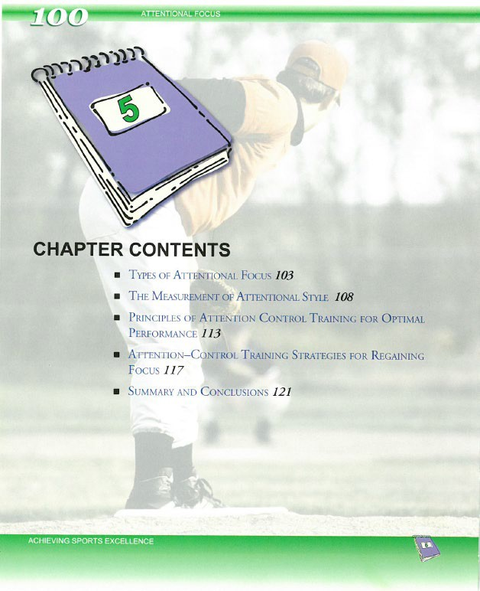

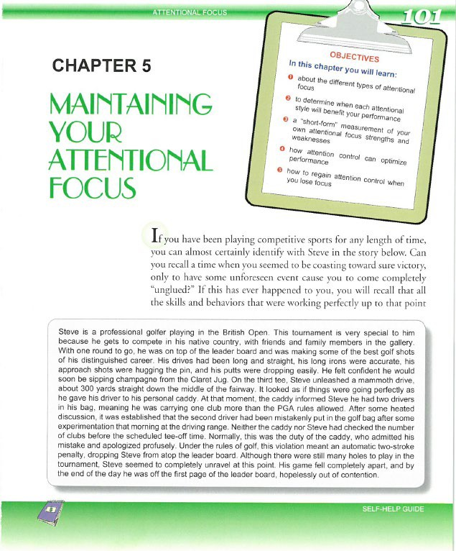

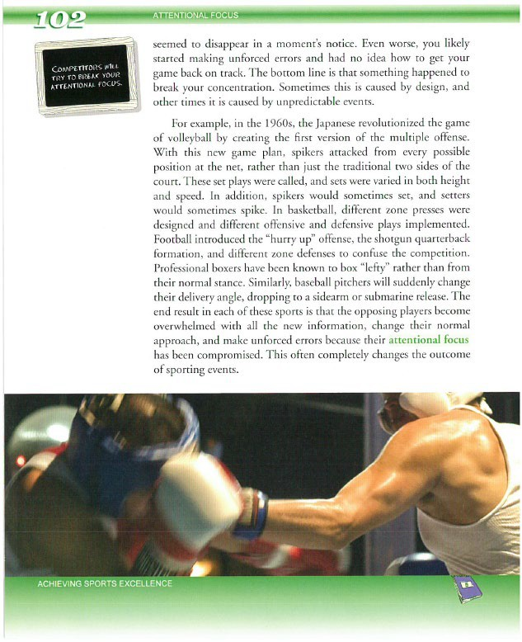

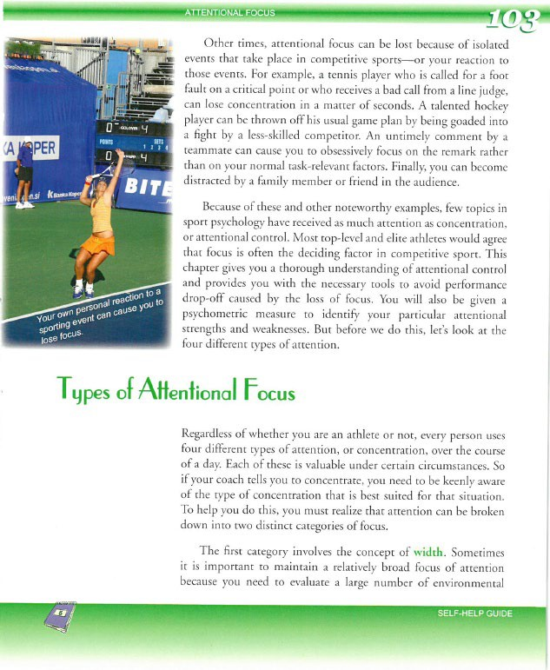

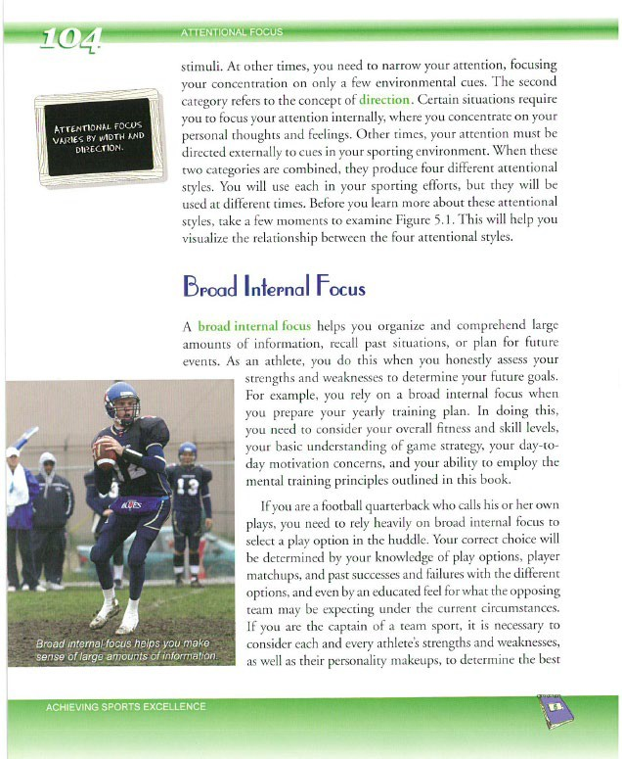

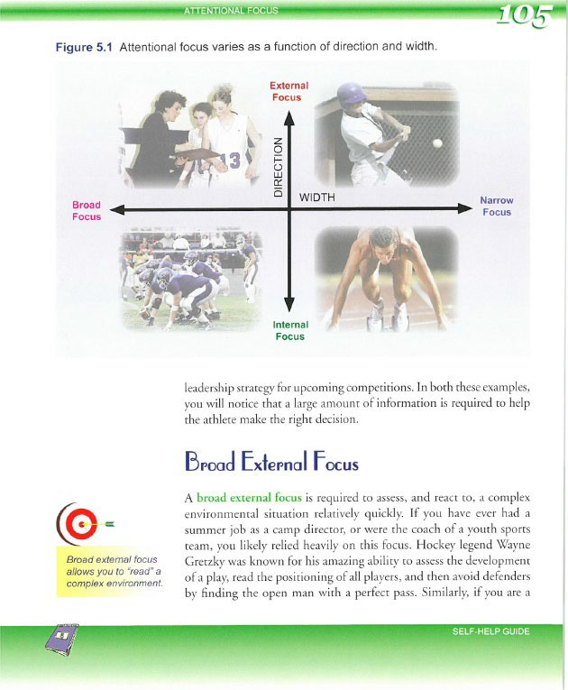

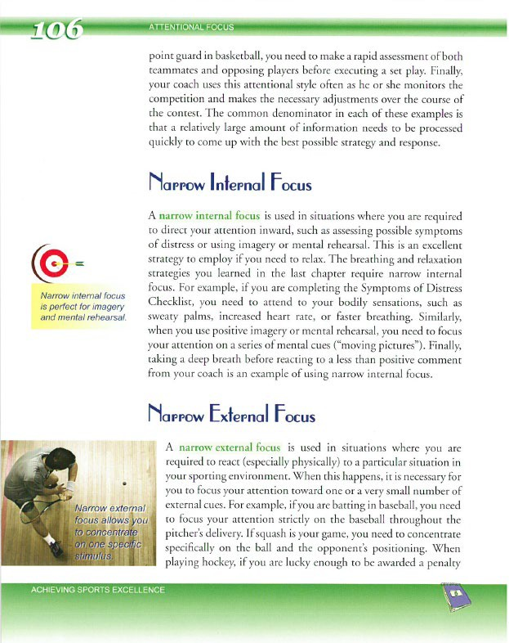

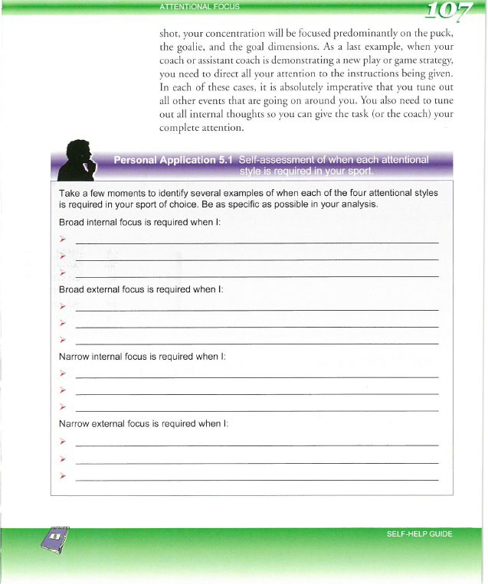

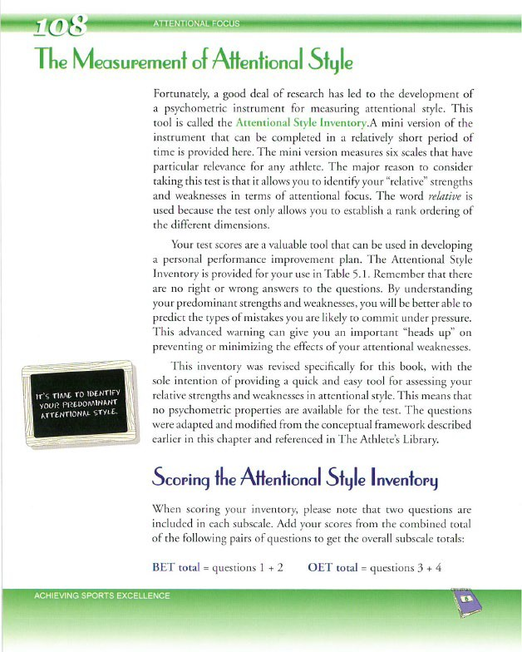

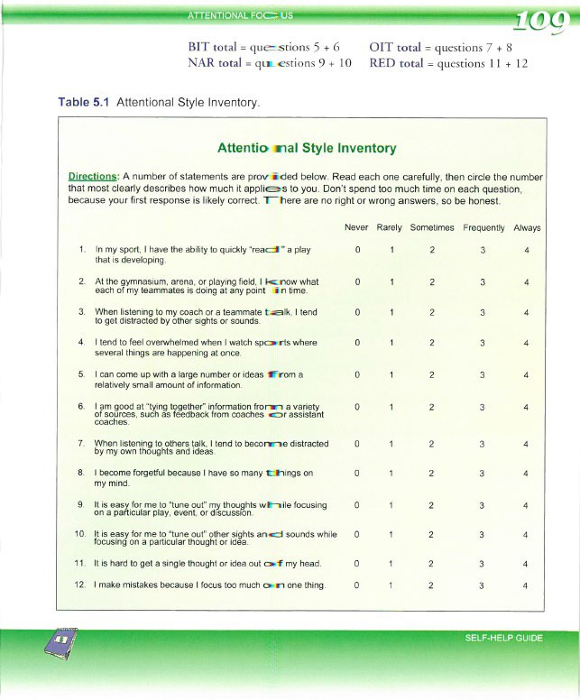

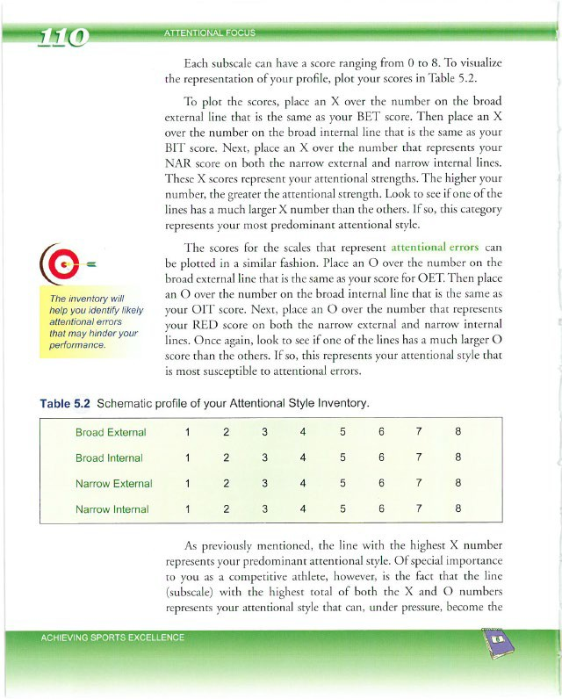

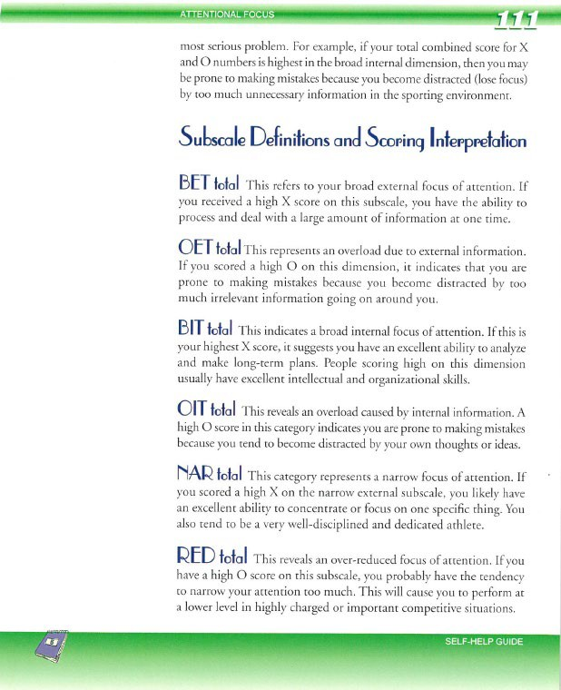

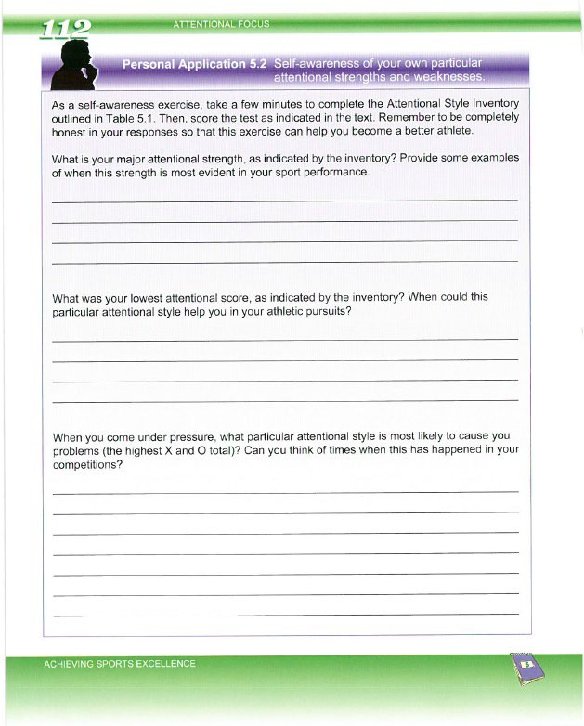

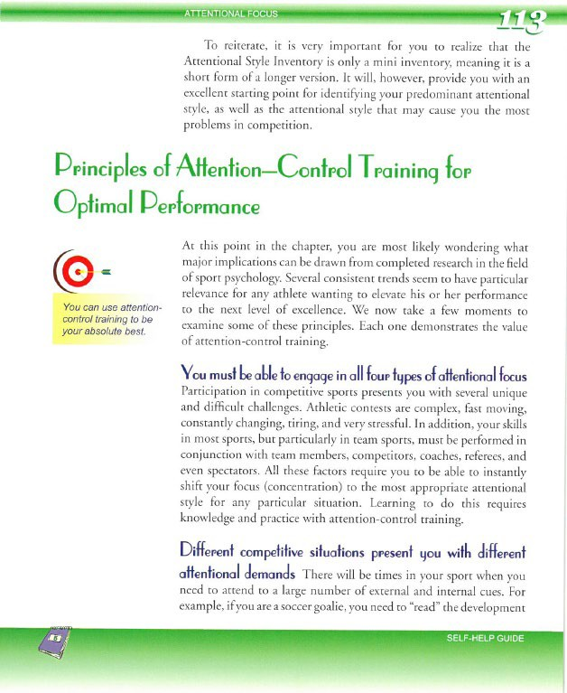

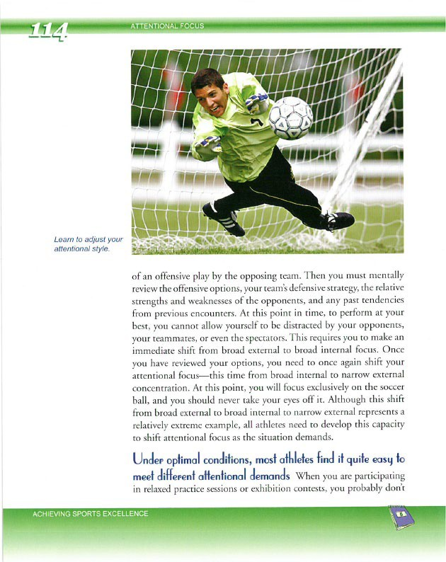

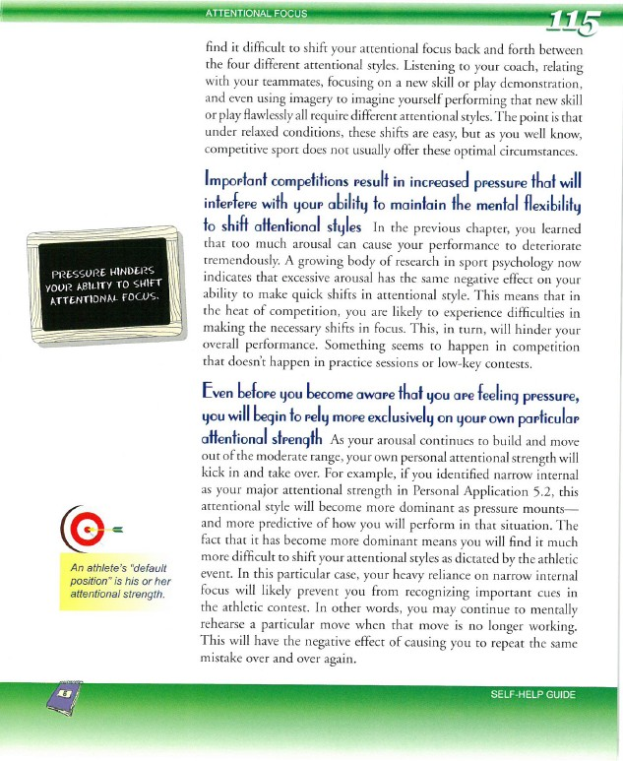

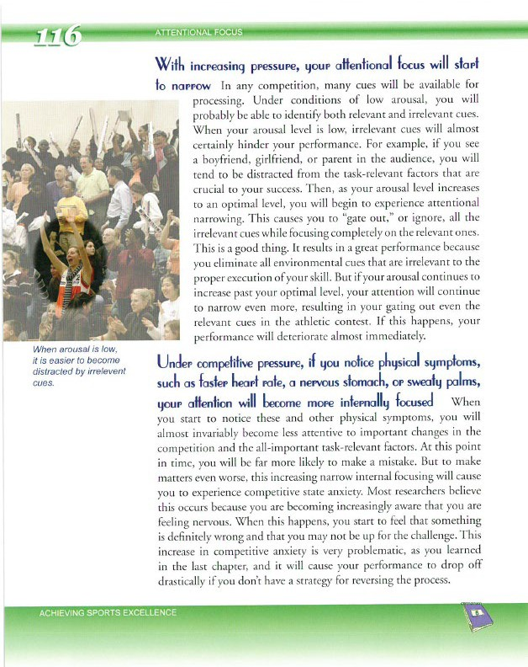

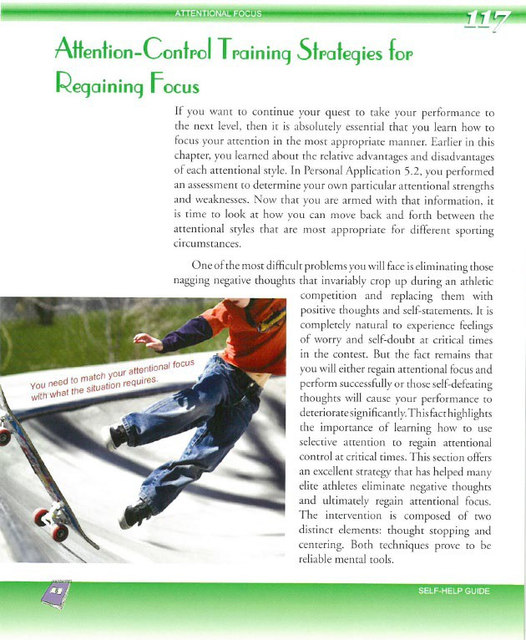

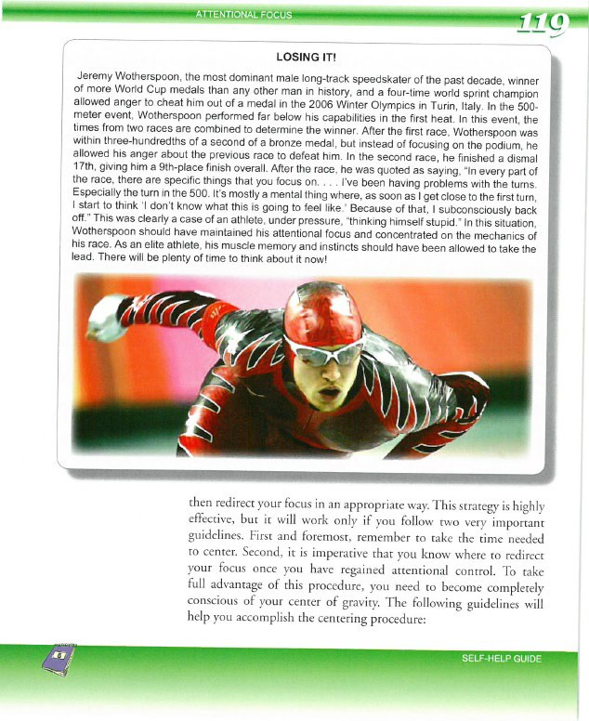

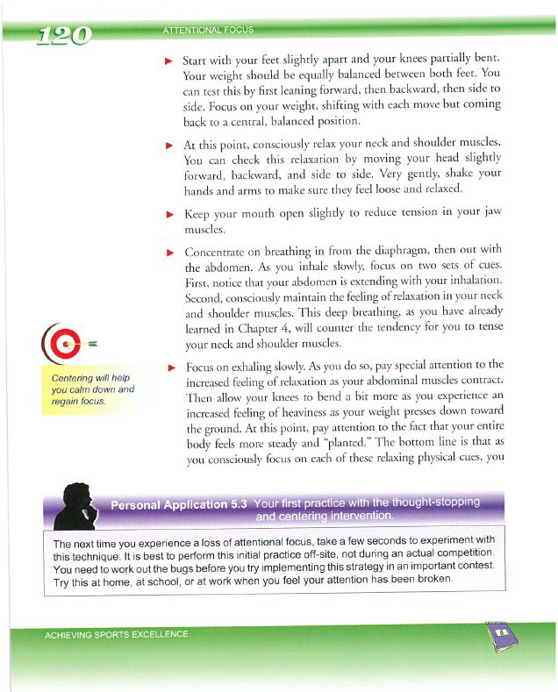

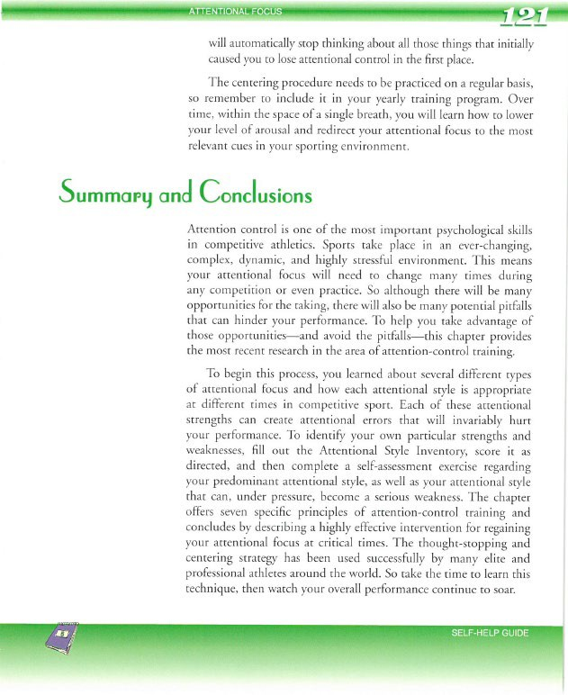

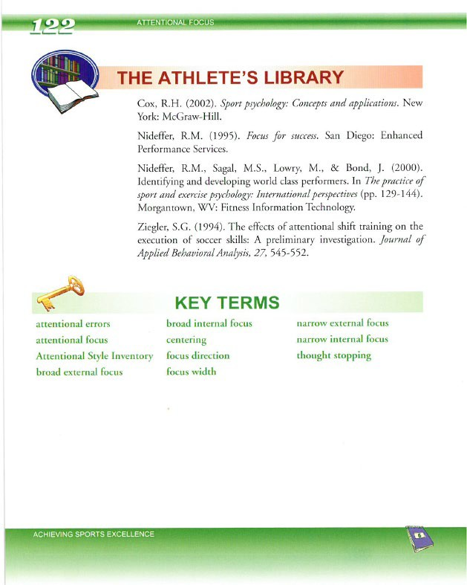

COURSE EVALUATION

Please click on this link, http://drake.qualtrics.com/SE/?SID=SV_9NU7ir8noyMxjZb to complete the online Course Evaluation for:

EDMA 173 The Teaching Coach

We value your opinion and will use your comments in future offerings. Thank you!

Note: If clicking on this link does not open your browser and take you to the survey, copy and paste the URL into the address bar of your browser. If you are using Internet Explorer and the link does not work, please try a different browser.

Coursework Submission:
Please see the first download called “Important Information” from your “Welcome” email for the procedure and portal submission link.

